PAGE 1 OF 6

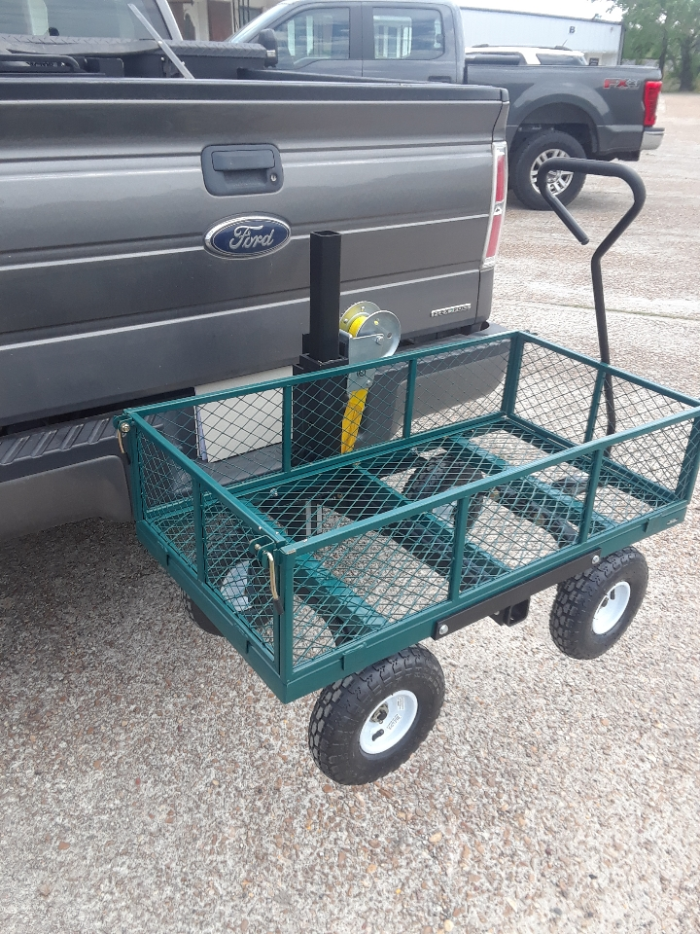

“HITCH-N- GO CART” LIFT ASSEMBLY
MODEL: HNGC LIFT ASSEMBLY

READ ALL INSTRUCTIONS AND WARNINGS BEFORE USING THE HITCH-N-GO CART
NOTE: Failure to read instructions AND WARNINGS before use could result in injury or death.
Instructions for Installation and Use:
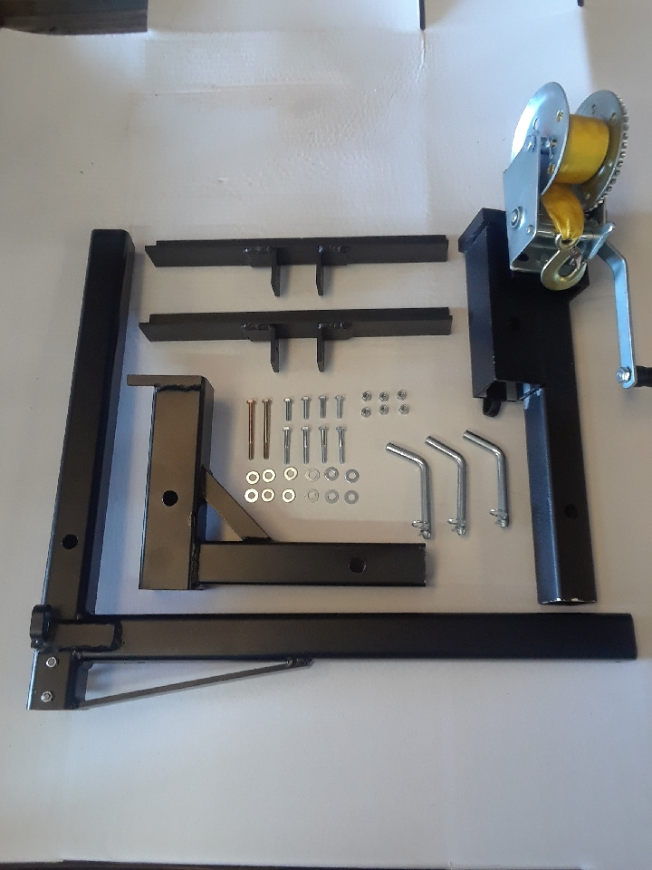
CONTENTS:
1-Receiver Adapter 6-1/4” locknuts
1-Winch Coupling 12-Flat washers
1-Cart Mount “L” Bar
2-Cart support brackets
3-1/2 Hitch pins with cotter pins
1-Winch Handle
2-1/4 x 3” bolts
4-1/4” x 1” bolts
4-1/4” x 1 ¾” bolts
STEP 1: Review contents to ensure all parts are received.

PAGE 2 OF 6
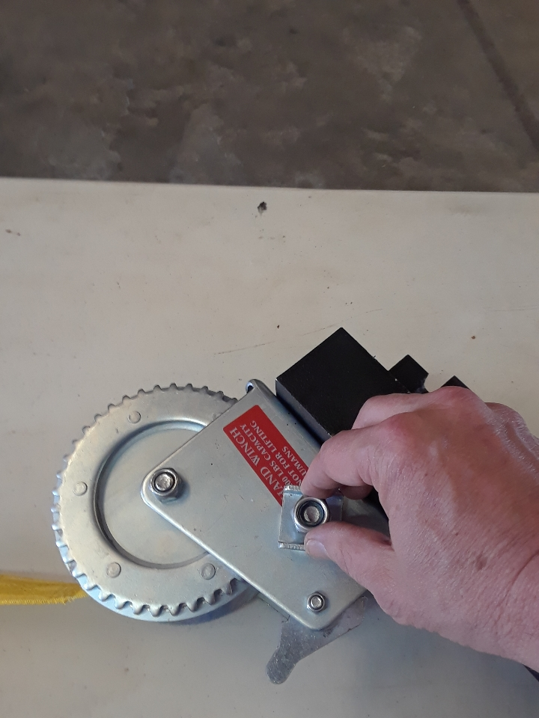
STEP 2: Remove nut from winch (FIG.1). Install handle, replace nut and tighten (FIG.2). Set aside for later use.

FIG. 1

STEP 3: Turn cart upside down on work surface with handle facing to your right. Center cart support bracket onto bottom frame of cart (FIG.3). Mark holes in bracket on the cart (FIG.4). Remove bracket and drill cart on marks using a 5/16” drill bit (FIG.5). Repeat this step with bracket on opposite side of cart.
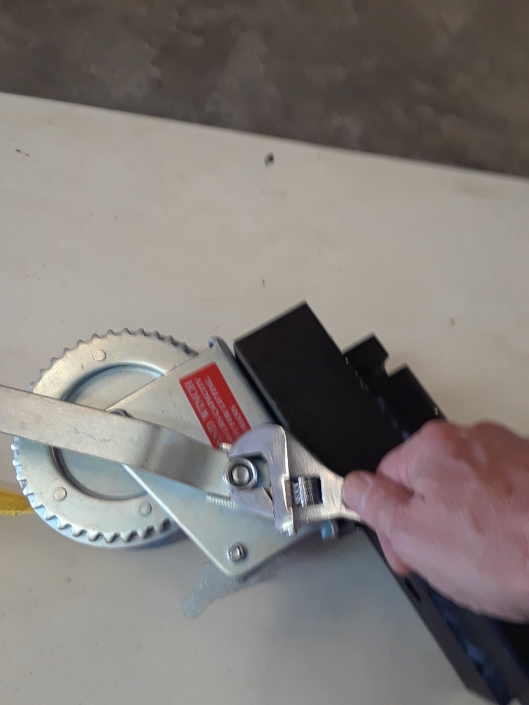

FIG.2
FIG. 2

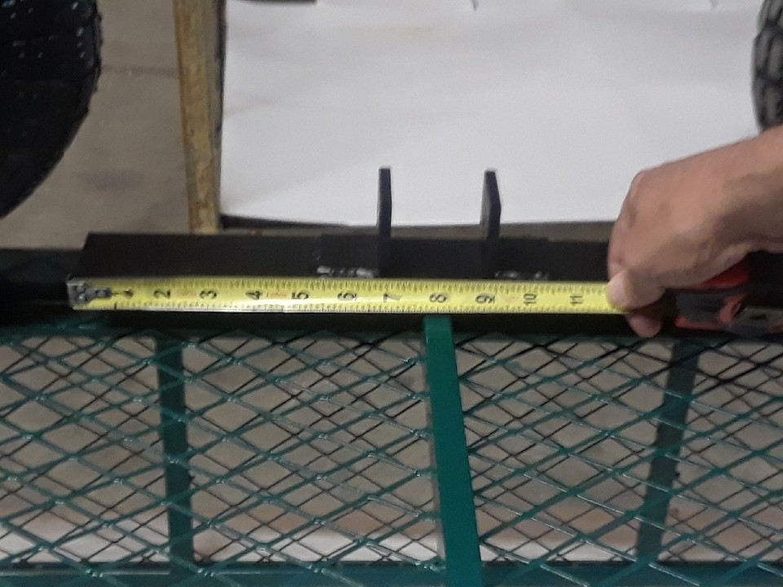
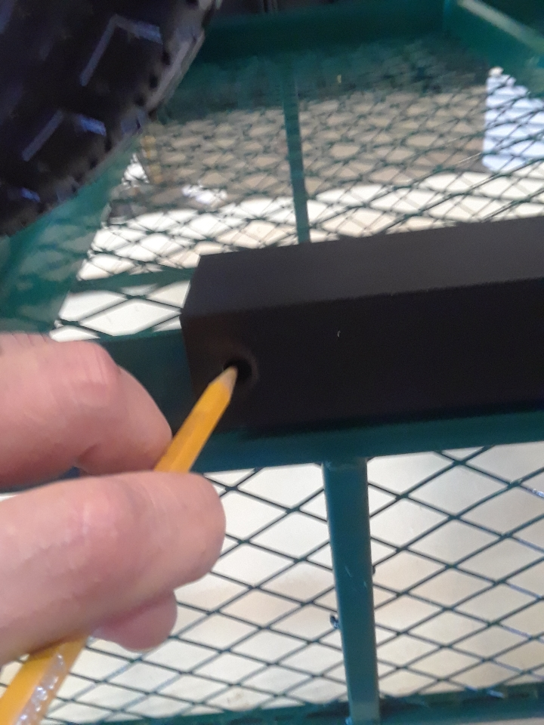

FIG.3 FIG. 4

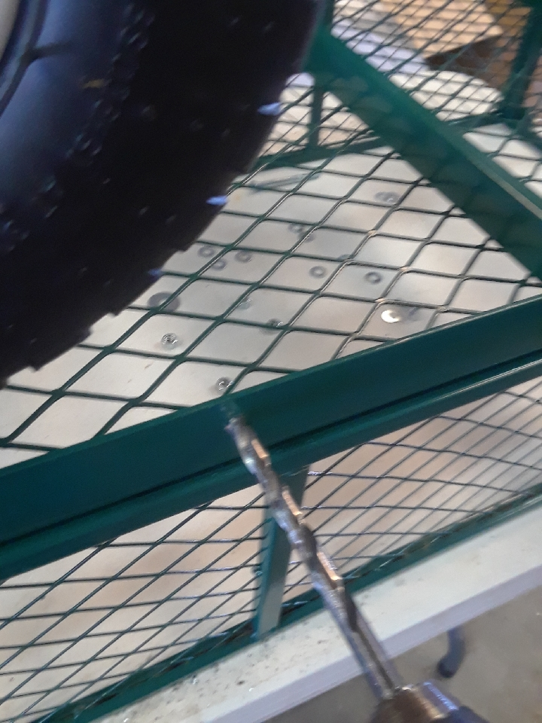
STEP 4: Place brackets back onto cart frame and attach with 4-bolts,8 washers and 4 locknuts. (NOTE: BOTH 1” AND 1 ¾” BOLTS ARE PROVIDED FOR YOU TO CHOOSE FROM). Use wrenches to tighten the hardware (FIG.6)

FIG. 5

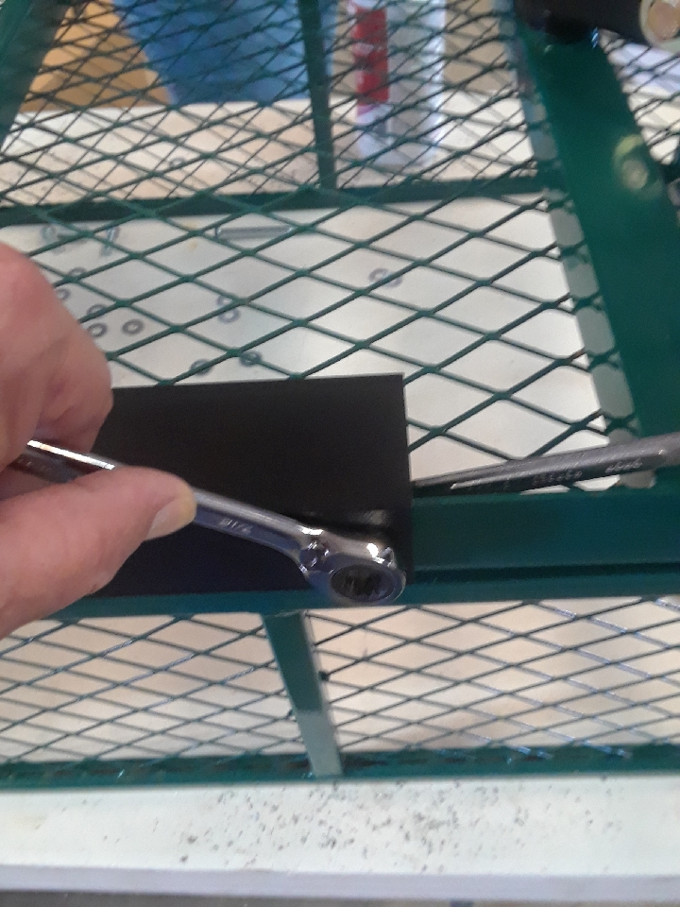

FIG. 6
PAGE 3 OF 6
STEP 5: Place cart mount “L” bar into support bracket with vertical part of “L” bar towards you and pointing down (FIG.7). (NOTE: MAKE SURE END OF BAR IS EVEN WITH THE OTHER SIDE OF CART). Mark hole on “L” bar for drilling (FIG.8)
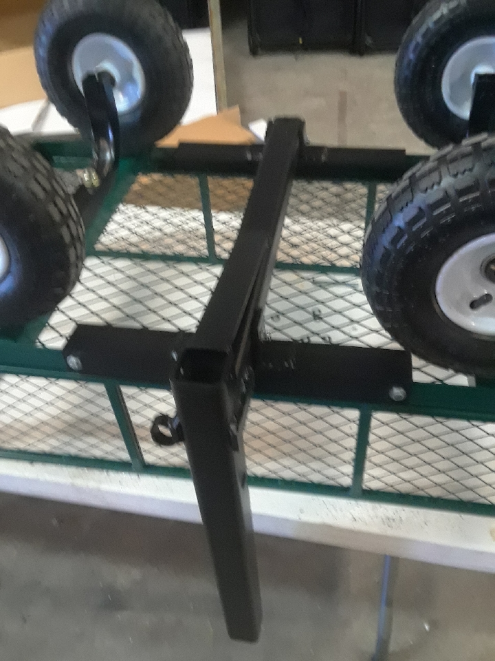

FIG. 7
STEP 6: Remove bar and drill on marks using a 5/16” drill bit. Return bar to brackets and attach with 2- ¼” x 3” bolts, 4- flat washers and 2 locknuts. Tighten bolts using wrenches (FIG.9). Cart can now be placed on its wheels.

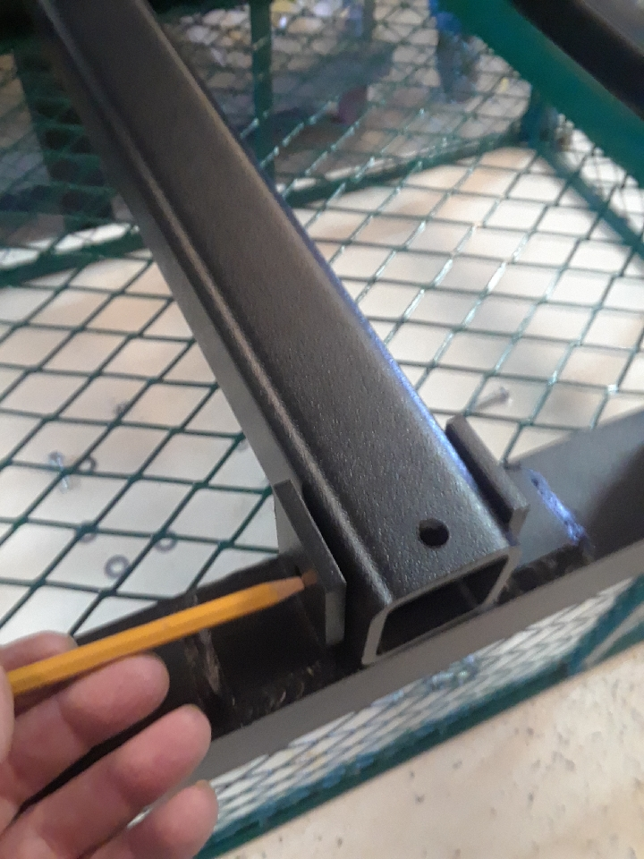

FIG.8

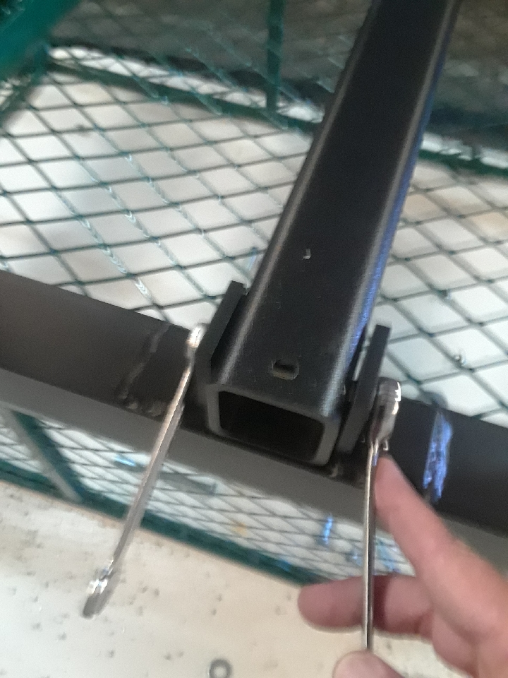

FIG.9

INSTRUCTIONS FOR MOUNTING TO VEHICLE
STEP 1: Install receiver coupling into vehicles receiver hitch. (FIG. 1). Secure with hitch pin and cotter pin. (FIG.2 NEXT PAGE)

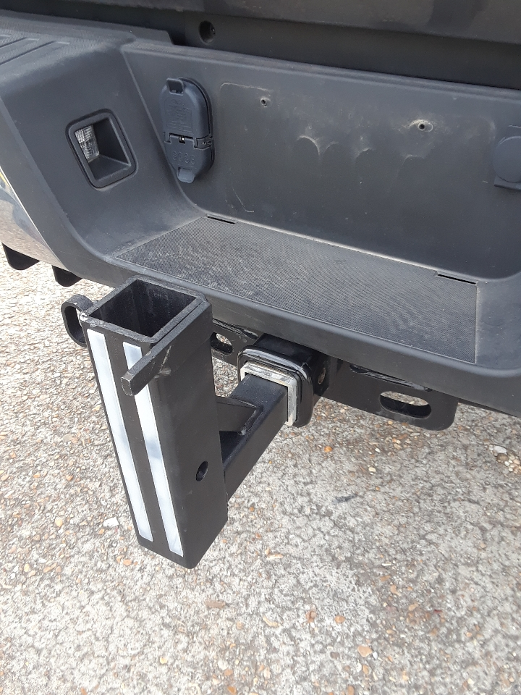

FIG. 1
PAGE 4 OF 6
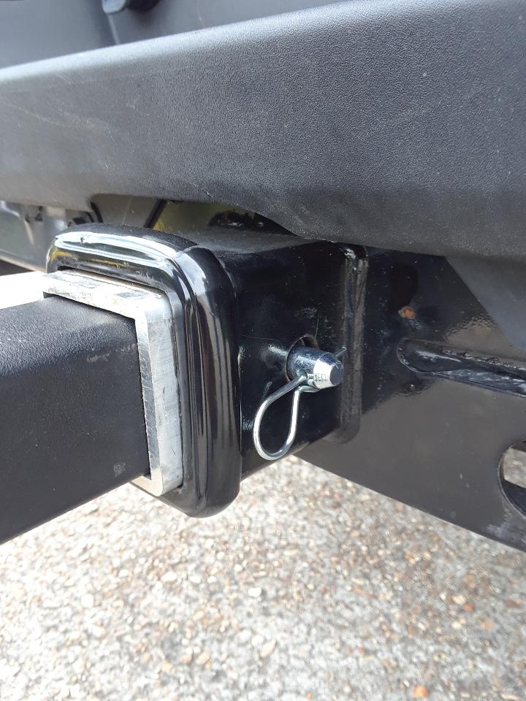
STEP 2: Roll cart up to the stop on the receiver coupling. (FIG.3) Slide winch coupling into receiver coupling and over cart bar. (FIG.4). Pin receiver and winch coupling together using hitch pin and cotter pin. (FIG. 5).

FIG.2
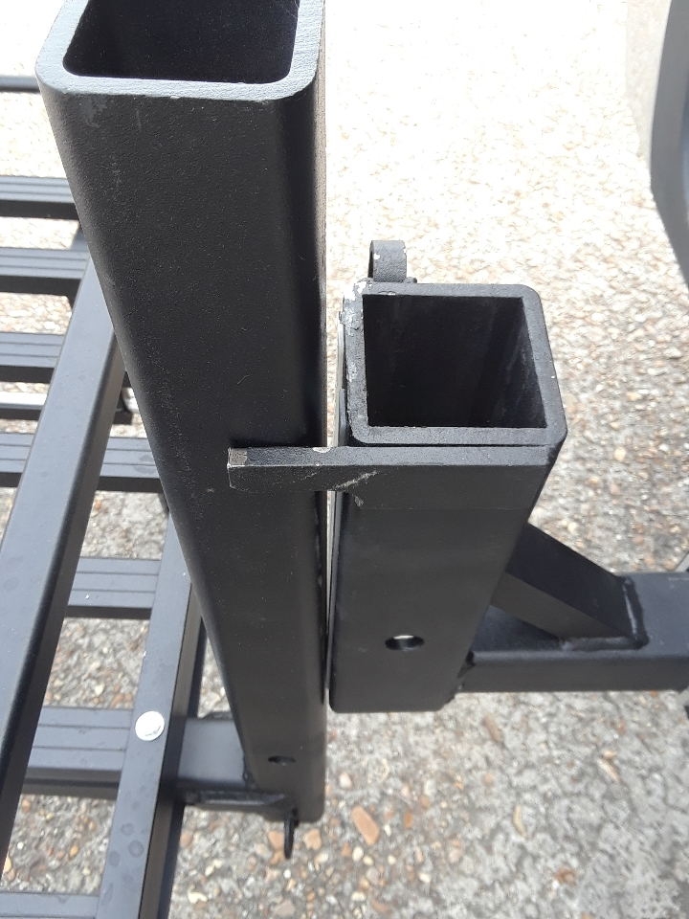

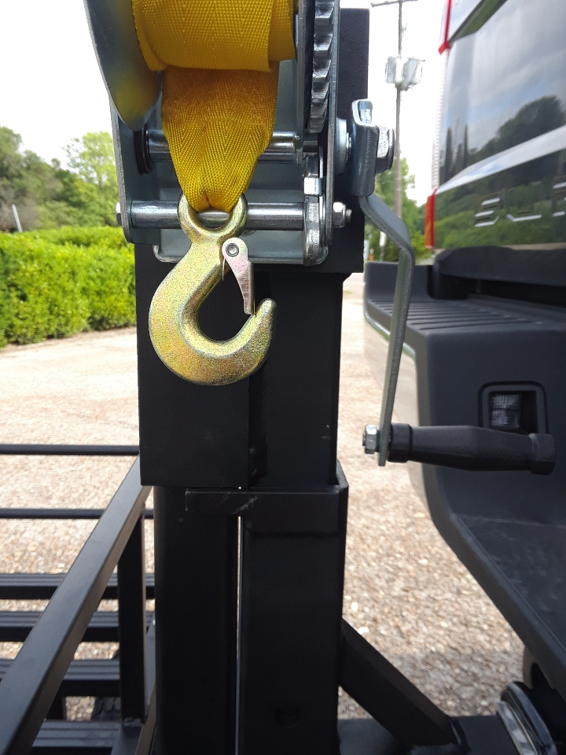

FIG.3 FIG.4
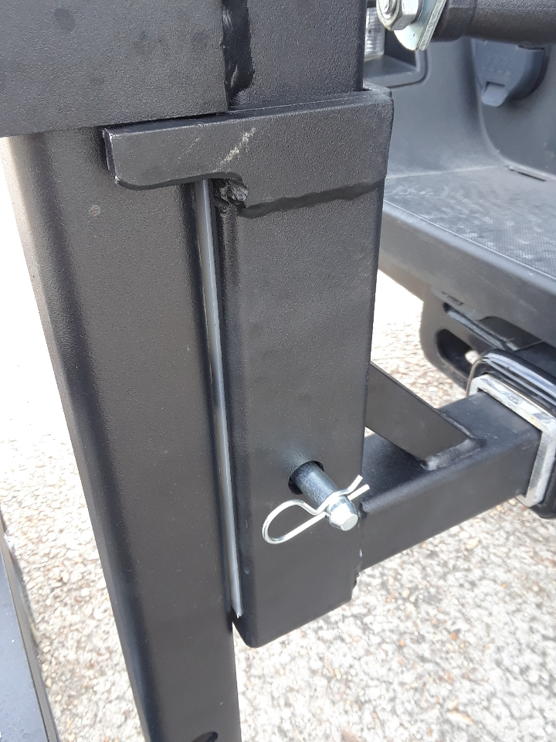

STEP 3: Release latch on winch and pull strap down and attach to cart bar. (FIGS. 6&7).

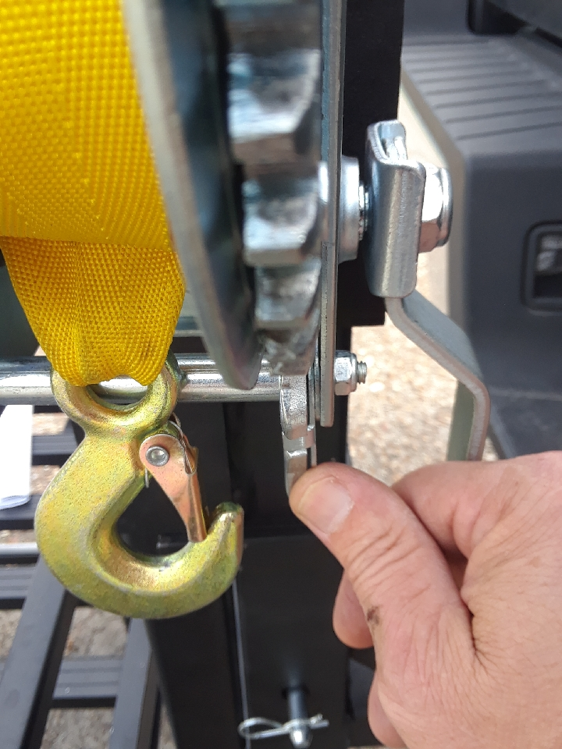
FIG.5

FIG.6

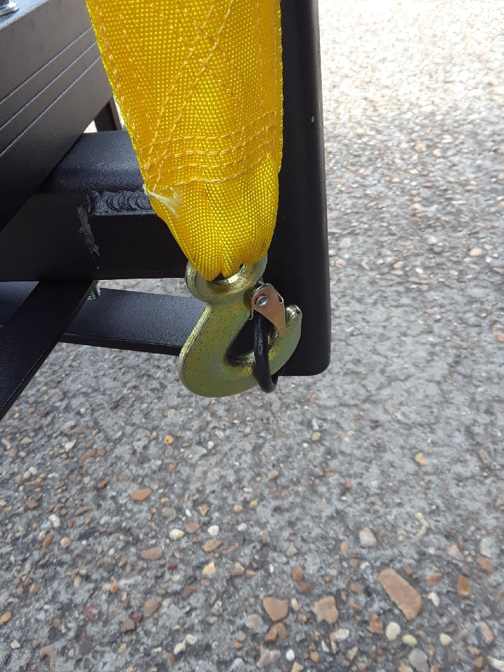
STEP 4: Engage winch and raise cart until it stops. Pin in place with hitch pin and cotter pin. FIGS. (8&9 Next Page)

FIG.7

PAGE 5 OF 6
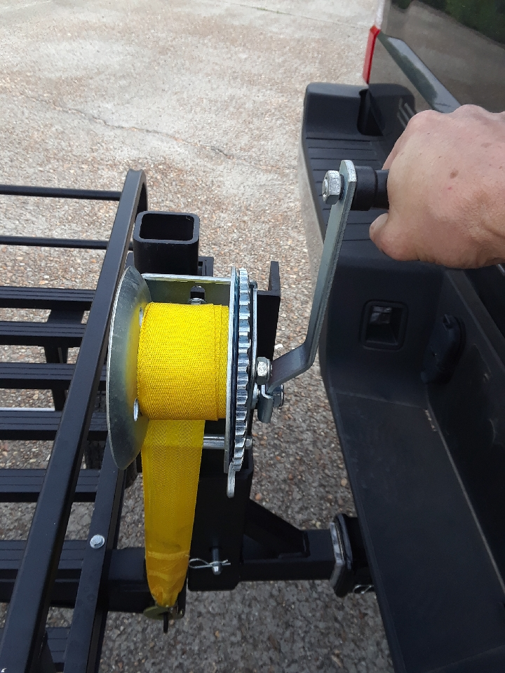
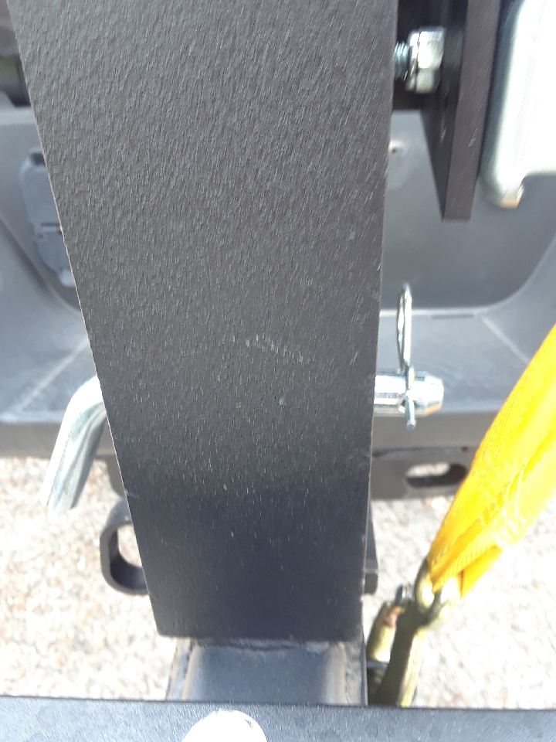

FIG.8 FIG.9

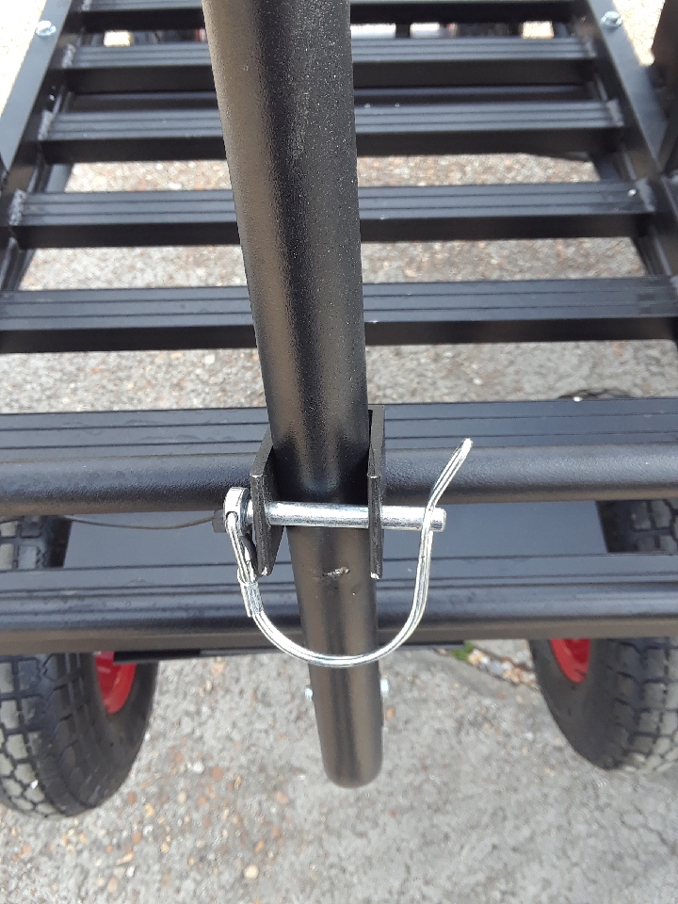
STEP 5: Secure handle to cart in its upright position using bracket and quick clip pin. (FIG. 10)

FIG.10

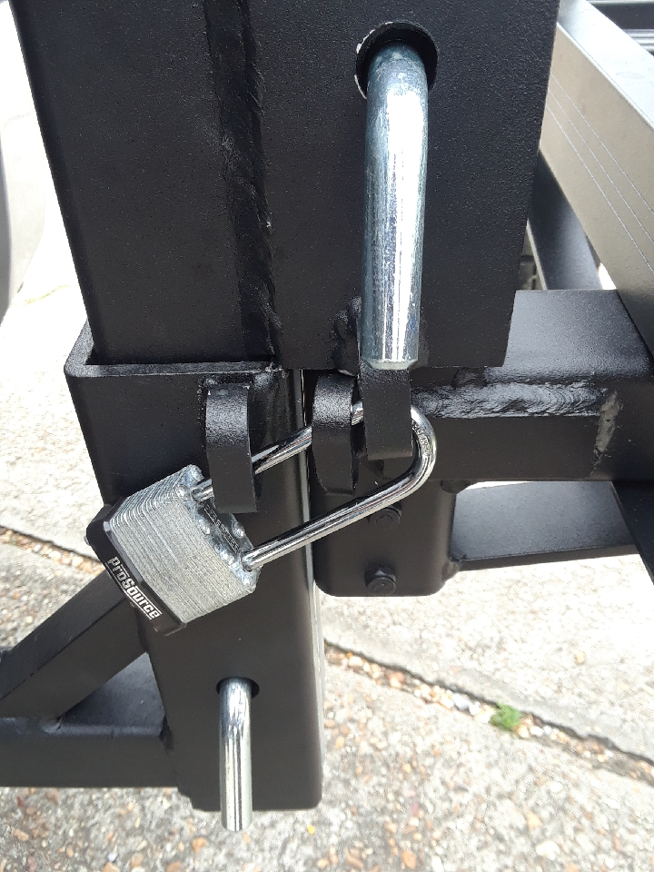
STEP 6: When cart is in its fully raised position, it may be locked in place using a long shank lock (NOT INCLUDED). (Fig 11)

FIG.11

STEP 7: To disconnect cart from vehicle, reverse steps 1-5. Winch coupling can be stored in vehicle and receiver coupling can be left installed on vehicle.

*WEIGHT CAPACITY OF THE LIFT ASSEMBLY IS 350 LBS. DO NOT EXCEED!!!
PAGE 6 OF 6
ALWAYS MAKE SURE HITCH PINS ARE IN PLACE AND SECURE!
DO NOT EXCEED WEIGHT CAPACITY OF HITCH-N-GO CART!
NEVER HAUL PEOPLE OR PETS IN CART!
ALWAYS MAKE SURE CARGO IS SECURED TO CART!
MAKE SURE HANDLE IS SECURED IN UPRIGHT POSITION BEFORE DRIVING!
USE THE WINCH TO CONTROL THE SPEED OF THE CART WHILE LOWERING IT. KEEP YOUR HAND FIRMLY ON WINCH HANDLE UNTIL CART IS COMPLETELY LOWERED TO GROUND!
For more information about this or other products, contact us at:
Great Day, Inc.
604 Kimbrough Dr. * Tallulah, LA 71282 * (866) 649-1918 * www.greatdayinc.com

